# **How To Get Start PPC In WordPress Website**

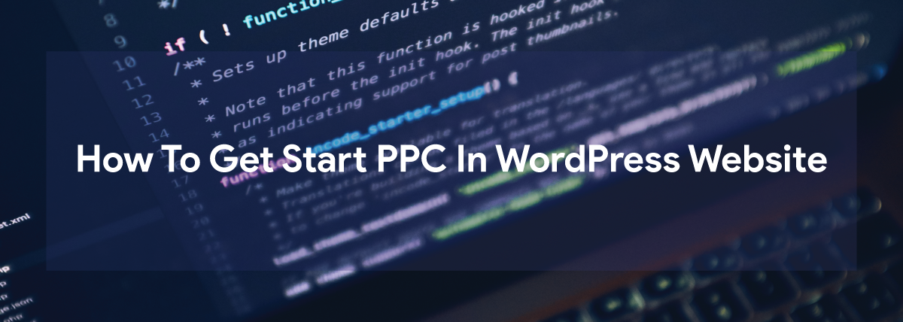

## What is blogging:

Blogging has been a supremacy in every role of the species. Blogging is very popular among people and they genuinely love doing it. Those people can do blogging who love expressing their thoughts and have a fervency to write about the topics. It is very popular as it is quite easy to write and has a lot of money. People can easily make money from it. Many companies hire content writers or bloggers to write about their product which will be later put on social media and search engines and make it more advertising.

## What do you know about wordpress websites?



Website is the approved way to create your own blogs. There are many websites on the internet powered by wordpress. It is an open source content management system which gives everyone an equal chance to write and modify their blogs. And importantly, it is free of cost. It is very easy to use and manage. You don't need a highly advanced brain to operate it. You don't require a developer to access this website.

What kind of website wordpress can make?

Wordpress provides a huge number of websites from business to ecommerce.

* Business websites
* eCommerce stores
* Blogs
* Portfolios
* Resumes
* Forums
* Social networks
* Membership sites

## Why should you go for wordpress?



Everyone uses wordpress nowaday. A business, a professor, student, companies, startups and many more. No one is confined to use wordpress and it is not particular that you need a developer only to use these websites. Microsoft also uses wordpress for their official blogs to get trendy on the internet.

### 

### I can give you plenty of reasons why you should go for wordpress.

* Wordpress is free and open source- As we all know wordpress is an open source software. Open source software is very useful these days because it comes with the advantage to use,modify,build and redistribute without paying any fees.
* Wordpress is extensible- We can create wordpress themes for clients,or other users and even for yourself. It provides you the extensibility to create themes that may be simple or complex according to your demand.
* It is easy to install- The most important advantage of Wordpress is that it is easy to install. It hardly takes 5 minutes to install and some of the shared web hosts offer tools that will help you install Wordpress in just a few clicks.
* It is quite flexible- Flexibility of Wordpress is the main reason why it is so popular to build a website. You can do many things on it like start a blog,make a small business website,creating an online store,running a market place and many more.
* It is a good platform to find help- It is a beginner friendly platform that provides you to create a website even with zero experience. It helps the newcomers a lot. It does not require some tough coding knowledge or anything to create a functional site.

## What are PPC advertisements?

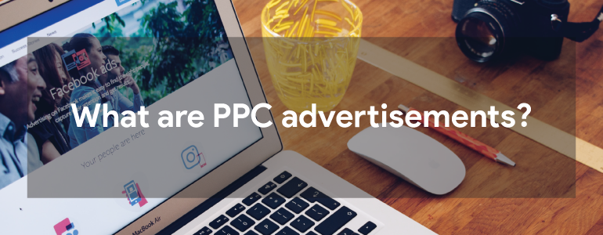

PPC, therefore pay-per-click. Ppc is the best form of online advertising over search engines. Everytime you pay when your advertisement is clicked. When you will get to understand the PPC ads, you will see them everywhere. They are present on almost every platform. Whenever you search anything on search engines a webpage with many websites appears and each of them have URLs. an add label is always present before url. Whenever someone will click on that url then you have to pay for that click. They are also present on social media also with the tag sponsors. These ppc advertisements are very much effective and drive a lot of traffic. They provide exposure to your brand on many platforms by targeting the specific audience. The people who will show interest in ads or will get engaged in them are very auspicious and optimistic people and you have to pay only for the click and you will get benefit. This is the best way to set a return of interest.

Careful use of [**lead generation companies**](https://www.commino.co.uk/services/lead-generation-companies/) can help to boost a lot of organic traffic and drive sales. You just need to implement it with careful planning.

### **There are some tips that will help ppc advertisements more effective:**

1. Choose a right platform- think wisely and intelligently and choose a right platform. What are the most used applications or browsers which have a lot of traffic? That is where you have to put ads. Google, instagram, youtube, facebook are such examples of platforms where you will find your audience. People mostly search their queries on google and this can be a better way to target your customers. It depends on the type of ad and then you can target your specific audience accordingly.
2. Select effective keywords- keywords are important if you are planning to drive more sales and get more traffic. It helps you to achieve success in your ppc ads. In wordpress and [**crm strategy**](https://www.commino.co.uk/services/crm-strategy-and-planning/) Making strategies is the best way to get the specific audience otherwise you will end up showing your ad to the people who have no interest in your product and your return of interest will get down. You have to make your customers realize that your product is their best choice by thinking of the best and most common keywords they use.
3. Optimize your ads performance- designing and putting your ad is not the only task you have to perform. You have to advance it and optimize its performance to get higher return of interest. Here you have to play perfectly. You have to track more customers and turn them conversions and also monitor that by which keyword you are getting more profits. Re-analyse your keywords and use them effectively. Every platform will have a different performance ratio. So what platform has been more productive for you? Just reconsider it and get more conversions.
4. Consider getting some help- Handling ppc at home is a really easy strategy. However it is time consuming and people without some experience often face difficulties. So many people consider hiring professionals from the ppc advertising agency ,these help you create some strong ads, monitor performance and can also adjust your results in the right direction.

## Wrapping up-

So these were the important tips that will help you to make your ppc advertisements more effective. Blogging is the most easiest and prominent field people are adapting and wordpress supports blogging in a superior way. Ppc ads are the best way to advertise your products online and get more audience for it. And if you do it with full strategy and planning you will get the good return of interest and will make your brand more popular.

________________________________________________________________________

**Description:** Everyone wants to bring traffic to their website. PPCeases this path, Here is the blog for those who want to get start ppc in wordpress website

**Keywords/Tags:**

1. **PPC in wordpress**
2. **PPC advertisement**
3. **Ads for wordpress**

**Authors Bio:**

**Name:**Anubhav Mishra

**Designation:** SEO Executive



Anubhav Serves as an seo executive at [**email marketing companies**](https://www.commino.co.uk/services/email-marketing-companies/), There he handles all work related from seo, smo and email marketing works.